**REPORT**

**CAPSTONE PROJECT- THE BATTLE OF THE NEIGHBORHOODS**

**Applied Data science capstone by IBM/Coursera**

**Analyzing Indian restaurants in the neighborhood of USA major cities**

**Parneet Kaur**

**22 August, 2020**

INTRODUCTION:

**BUSINESS PROBLEM**

The United States of America (USA), commonly known as the United States (U.S. or US) or America, is a country [mostly located](https://en.wikipedia.org/wiki/Contiguous_United_States) in central [North America](https://en.wikipedia.org/wiki/North_America), between [Canada](https://en.wikipedia.org/wiki/Canada) and [Mexico](https://en.wikipedia.org/wiki/Mexico). the U.S. is the [third most populous country](https://en.wikipedia.org/wiki/List_of_countries_and_dependencies_by_population) in the world. [Americans](https://en.wikipedia.org/wiki/Americans) are a [racially](https://en.wikipedia.org/wiki/Race_(classification_of_human_beings)) and [ethnically](https://en.wikipedia.org/wiki/Ethnic_group) [diverse](https://en.wikipedia.org/wiki/Multiethnic_society) population that have been shaped through [centuries of immigration](https://en.wikipedia.org/wiki/History_of_immigration_to_the_United_States). The capital is [Washington, D.C.](https://en.wikipedia.org/wiki/Washington,_D.C.), and the [most populous city](https://en.wikipedia.org/wiki/List_of_United_States_cities_by_population) is [New York City](https://en.wikipedia.org/wiki/New_York_City). According to the [2010 United States Census](https://en.wikipedia.org/wiki/2010_United_States_Census), the Asian Indian population in the United States grew from almost 1,678,765 in 2000 (0.6% of U.S. population) to 2,843,391 in 2010 (0.9% of U.S. population), a [growth rate of 69.37%](https://en.wikipedia.org/wiki/Demographics_of_Asian_Americans), one of the fastest growing ethnic groups in the United States. Although Indian food makes up less than two percent of the ethnic food market in the United States, it has had the fastest growing rate. Indian-American chefs are becoming very popular in the burgeoning foodie movement in the U.S. because diners are excited to try ethnic cuisine, and Indian chefs who are able to bring interpretations of ethnic flavors through the use of modern techniques are finding success. So, my project is to analyze and cluster the Indian restaurants in the US in the major cities of US i.e. New York, Los Angeles, Chicago. Let’s look at the data and cluster and analyze these restaurants based on their liking.

**DATA SOURCES**

The biggest challenge here is to get the relevant and correct data for the problem. Since I’m considering only the three major cities of the US i.e. New York, Los Angeles and Chicago. I need to use the foursquare API’s to collect data regarding these three major cities of the US. As these are the most populated cities in the US, we need to find the Indian restaurants in these cities and analyze each of them.

**METHODOLOGY**

* Firstly, I chose the three major countries of USA in every respect.
* Then used the python tools.
* Installed geo-coders and folium for plotting maps.

**RESULTS**

There are a variety of Indian restaurants in the major cities of USA i.e. New York, Chicago & Los Angeles and one can easily find these and choose a particular restaurant according to our need. Hence, I successfully analyzed and clustered the three major cities of USA on the basis of the Indian cuisines.

**CODE**

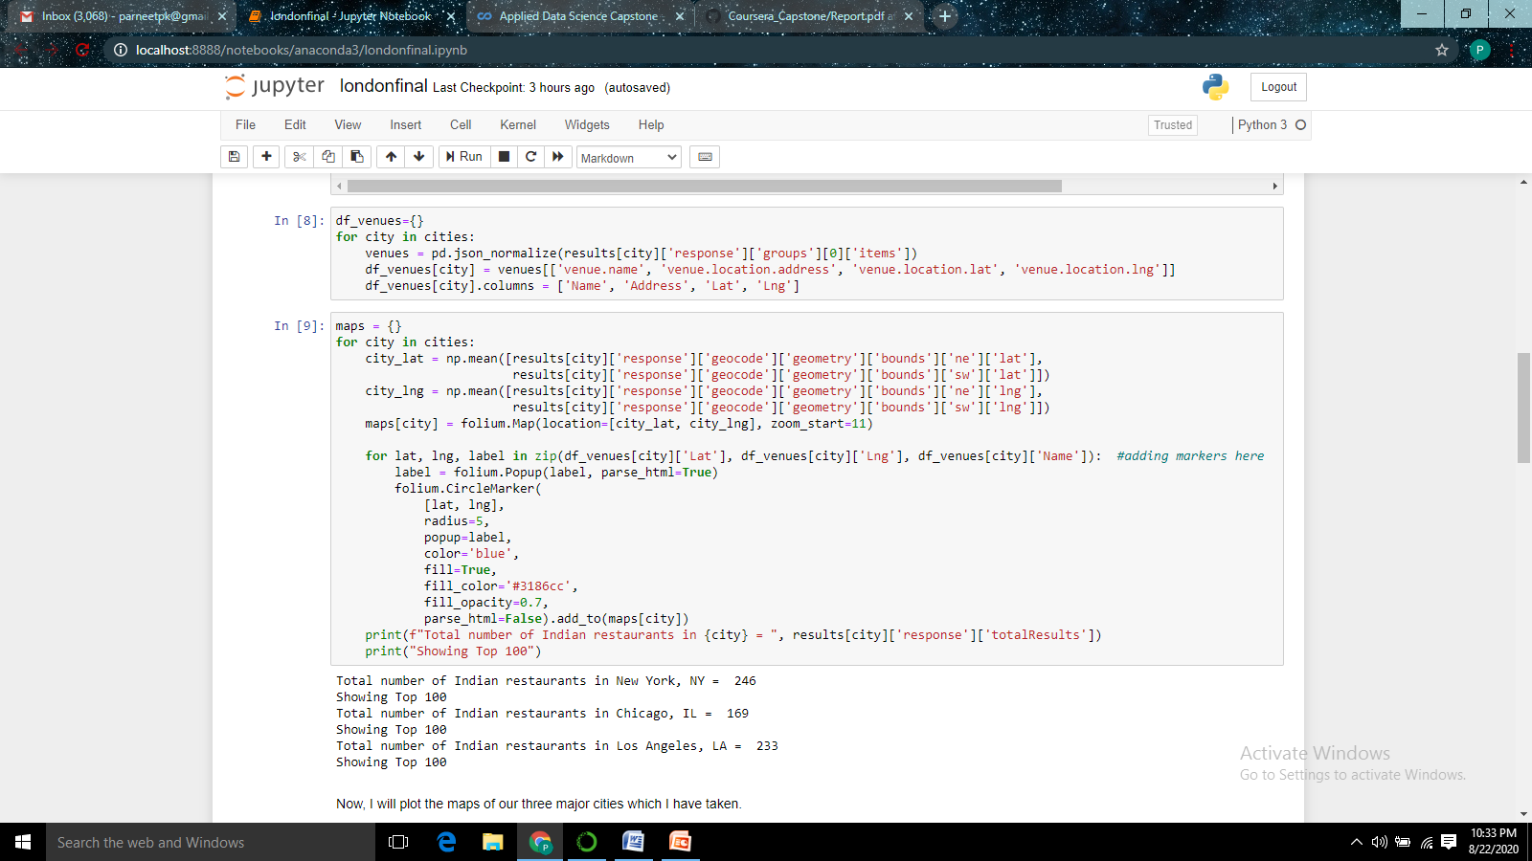

Here, I found that New York has the largest number of Indian restaurants with 249 in number, followed by Los Angeles with 233 and Chicago with 169 in total. So, NY would be a good place to reach for great Indian restaurants with a great variety.

**MAPS**





